Step 7: Variable Costs and Contribution Margins
Thyssenkrupp operate as a large German steel conglomerate providing engineering equipment internationally across multiple industries.

For the purpose of this step, three products have been chosen from Thyssenkrupp’s main operations:
- Escalators – Synergy 100
- Bearings – Slew bearing for Hitachi EX5500
- Coil springs – Linear coil spring for a 930E-4 Komatsu dump truck

As escalators form part of one of the largest departments in the company, I found it appropriate to include this product. Deciding between the other areas of steel production came down to my personal choice. Working in a coal mine, I have direct exposure to maintenance days/shutdowns on excavators which often involve the replacement of slew bearings. My third decision was based more on my interest between sale prices of significantly larger steel products compared to small products.

In order to compare the contribution margins of each of these products, a standard measurement of Euro per tonne has been used:
- Synergy 100 (8t) – 440€/tonne = 8 x 440€ = 3,520€
- Slew Bearing (3t) – 700€/tonne = 3 x 700€ = 2,100€
- Linear Coil Spring (0.6t) – 860€/tonne = 0.6 x 860€ = 516€

Variable costs are…. The variable costs associated with Thyssenkrupp’s steel production would include labour, electricity, ….
The variable cost percentages that have been allocated to these three products are:
- Synergy 100 – 60%
- Slew Bearing – 70%
- Linear Coil Spring – 70%

The variable cost of each product:
- Synergy 100 = 0.6 x 3,520€ = 2,112€
- Slew Bearing = 0.7 x 2,100€ = 1,470€
- Linear Coil Spring = 0.7 x 516€ = 361.20€

Contribution Margin (CM) = Sales Price (SP) – Variable Cost (VC)
- Synergy 100 = 3,520€ - 2,112€ = 1,408€
- Slew Bearing = 2,100€ - 1,470€ = 630€
- Linear Coil Spring = 516€ - 361.20€ = 154.80€

Contribution Margins of Thyssenkrupp
Contribution margin is the difference between sales revenue and variable costs. For Thyssenkrupp, their variable cost percentages are understandably very similar. As their main business deals in the production of steel, it is predicted that the manufacturing of each steel product would have similar variable costs. The most noticeable difference would be attributed to the differences in time taken to produce different products which could be dependent on size. This is relevant for the three products that have been chosen as they vary significantly in size and weight. It is important for Thyssenkrupp not to discontinue production of products with smaller contribution margins. Taking into consideration the time factor when producing these products, more slew bearings would be able to be produced in the time it takes to manufacture one escalator, and even more linear coil springs could be produced in this time.

With the mining industry being a great source of revenue for steel manufacturers, Thyssenkrupp should not discount the reduced contribution margin of the smaller steel products as they are in high demand.

Possible Constraints
A constraint is anything that prevents a system from achieving a higher performance relative to its goal. The goal of Thyssenkrupp is to produce and distribute large amounts of steel through a variety of products. A possible constraint that might be faced in this industry relates to resource constraints. Without adequate resources, production could experience disruption. This was the reality for Thyssenkrupp in recent years as production was restricted due to low water levels on the River Rhine, which meant reduced shipments following the introduction of new emission standards in the auto industry. An area to address to avoid these resource constraints would be waste management. By minimising Thyssenkrupp’s waste amount, and reusing products, material constraints could be significantly reduced.

Aside from these resource constraints, Thyssenkrupp also face market constraints. Dealing in such heavy products, companies may select to source their steel from the closest manufacturer to the site requiring the product. This means that Thyssenkrupp are subject to constraints from location and competition.

These constraints are relevant in the decisions of quantities of production for the three products mentioned above. If the required resources are not available, it is important not to overproduce and limit the firm’s ability to produce other products that may be in higher demand. It is important to monitor the market through competitive analysis and keep up to date with current clients. By maintaining awareness of customer needs, Thyssenkrupp can overcome these constraints to identify how much they should produce and sell of each product.

Step 8: Ratios
Prior to attempting my firm’s ratios, I felt comfort in knowing another video had been supplied by Maria. Without these videos to guide me through restating my financial statements, I would have been completely lost. The amount of explanation provided by Maria was incredible. So, having this previous support took away some of the concern I would have been feeling otherwise.

I’m not sure what I was expecting ratios to be like, but I found them very self-explanatory, plus Maria’s additional clarifications definitely helped. I struggled in two areas, mainly due to my excel capability. When it came to listing my number of issued ordinary shares, they were listed in millions. I tried multiple ways of entering this number but no matter what I entered, when linking later my ratios all equalled zero. My other concern was with my negative numbers. I noticed that Maria had negated her negative numbers when they were negative across all years, but mine were always only for two or three of the years in a particular row. So…____________________________

Profitability Ratios
I found Thyssenkrupp’s net profit margin to be very concerning. I understand this ratio to represent how much profit they have generated from every euro of their sales. The best they have performed in the last four years was 2015, dropping very low in the following years. Their return on assets follows the same trend with figures virtually mirroring the net profit margin. Although this is concerning, it is not all that surprising. As I learnt from my financial statements that the company has experienced poor results in financial performance in recent years due to management issues and the discontinuation of several branches, a low profitability ratio is accurate.

When comparing Thyssenkrupp’s profitability ratios to other companies, I notice that other companies are achieving much greater results. For Gallifordtry, they maintain a fairly consistent trend between 3-5%, apart from 2017. Could this be a one off that they ignore?

For (other company)______________________



Efficiency Ratios
The Days of Inventory ratio shows the number of days it has taken to sell inventory. It is important to maintain an appropriate period for attaining inventory to ensure that supplies can be met, and enough stock is kept for when it is required. However, I believe the days of inventory for Thyssenkrupp are too high. They have maintained somewhat of a trend over the last four years, peaking in 2017. Since then, the figures for 2018 are the lowest they have been over that period. This is positive. This could mean that Thyssenkrupp are monitoring their inventory and gaining accuracy when ordering stock.

The Total Asset Turnover ratio reveals how much of each euro of assets the firm is turning into revenue. For most years, except for 2017 where they fall to 0.97, Thyssenkrupp are at least making a 1:1 asset turnover. In 2018, they managed to increase their revenue to above 1 euro (marginally).

When comparing Thyssenkrupp to Gallifordtry I notice that Thyssenkrupp are actually more efficient with their days of inventory. In 2015, Gallifordtry doubled in their days of inventory. With both companies heading in the right direction and reducing their days of inventory in 2018, Gallifordtry still exceeds Thyssenkrupp by 37 days in inventory.

Other company ______________________________________________________


Liquidity Ratios
The Current ratios express how many euros in assets we have available to pay for each euro we have in liabilities. Thyssenkrupp maintain a consistent trend across all four years, coasting between 0.13 and 0.20 above 1 euro. As they have enough assets to cover their liabilities, I believe this is positive.

In comparison to Thyssenkrupp, Gallifordtry are doing slightly better. In previous years, they had ample assets to cover their liabilities. A gradual decrease has been noticed, although still leaving them with a higher current ratio then Thyssenkrupp in any year. As Thyssenkrupp have experienced the discontinuation of branches involving a significant increase in assets held for sale, this could explain why their assets are not as high as Gallifordtry’s.

Other company ______________________________________________
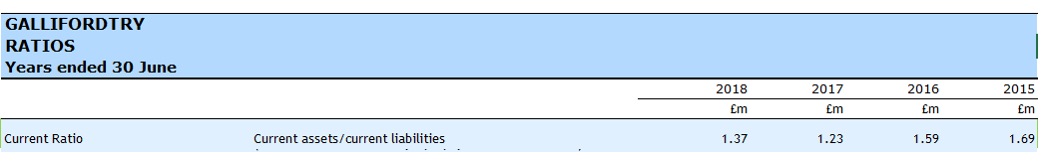

Financial Structure Ratios
The Financial Structure Ratios reveal how the company is funded. The Debt/Equity Ratio tells us how much an outsider (bank) is contributing for every euro of equity the firm has. From Thyssenkrupp’s Debt/Equity Ratio, we can see that the contribution from outsiders is quite high. When looking back at the firm’s financial statements, total liabilities significantly outweigh total equity, so these figures are not surprising.

The Equity Ratio tells us what percentage is funded by Thyssenkrupp, the owner. Noticeably low percentages have been recorded as contributions from Thyssenkrupp. As was revealed in the last ratio, most of the firm’s funding comes from outsiders. Calculating the debt ratio helped to view the split of funding between owners and outsiders. It surprises me that such a high percentage is contributed by outsiders, which would increase Thyssenkrupp’s liabilities, yet the firm still manage to maintain enough assets to cover these liabilities. With their assets decreasing each year, how long can they keep this up?

When comparing figures to Gallifordtry, my concern for Thyssenkrupp’s significant outsider contribution is heightened. How can their Debt/Equity Ratio be so low? But then I see Paul has also used the Debt Ratio to express the percentage of owner and outsider funding. Although Thyssenkrupp’s is way up around 90%, Gallifordtry still trend around 70% which is still high. Is this a bad thing? I believe that Thyssenkrupp could benefit from increasing their assets and achieving more of a balance in the owner/outsider funding ratio.

Other company _____________________________________

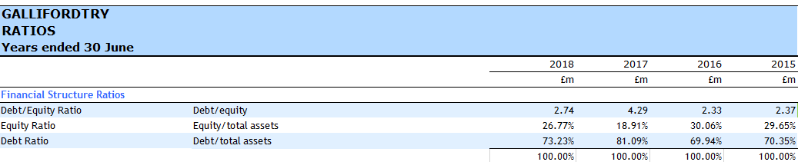

Market Ratios

Ratios Based on Reformulated Financial Statements

Economic Profit

Step 9: Capital Investment Decision
When faced with an opportunity to acquire a new business to assist in Thyssenkrupp’s current productions, the decision between a chemical plant and a cement plant must be made. Both will contribute to current steel production as an asset to the firm.
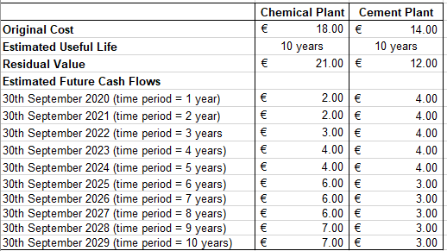

Option 1: The Chemical Plant
The chemical plant will be purchased for €18million and have an expected life of 10 years before being sold off or undergo a major shutdown. As the chemical plant is predicted to maintain its value, and a consideration has been made in the future cash flows to account for upgrades and maintenance, the residual value will actually increase to €21million.
NPV = With a Net Present Value of €7.87million we can project that this investment would be profitable.
IRR = The expected rate of return on the initial investment would be 17.25%.
Payback Period = It would take 5 years and 6 months to recover the costs of purchasing the chemical plant.
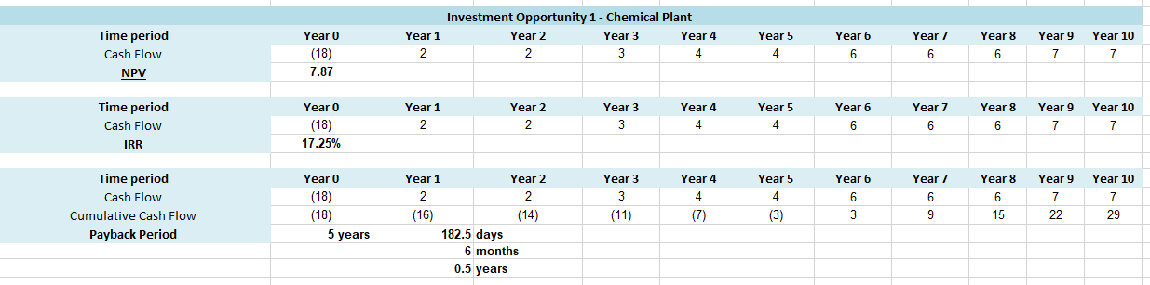

Option 2: The Cement Plant
The cement plant will be purchased for €14million and have an expected life of 10 years also before being sold. The residual value of the cement plant will be €12million.
NPV = With an NPV of €17.32 we can predict that this would be a highly profitable investment.
IRR = The expected rate of return on the initial investment would be 23.48%.
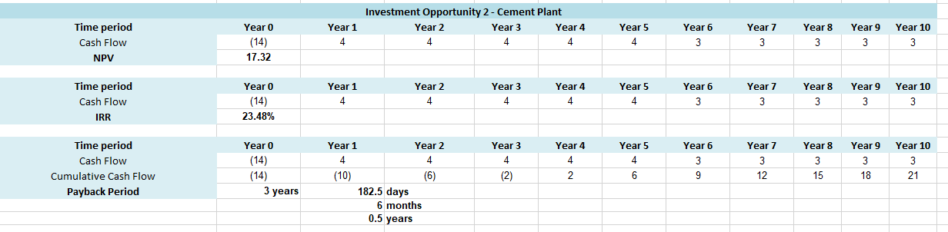
Payback Period = It would take 3 years and 6 months to recover the costs of purchasing the cement plant.

Investment Decision
When conducting the above analysis to determine the NPV, IRR and payback period of each investment, some clear differences can be acknowledged as a strength in choosing between investment decisions. By conducting the analysis, we can clearly separate the two options and allow an individual assessment of each. As the two plants will provide similar services to the firm, it is appropriate to compare the two in this manner, over the same time period.

A weakness of this analysis is that we cannot accurately predict the future cash flows of each investment. Although we have experience and other departments in our firm to reference, the future is not definite, especially considering our firm’s decreased financial performance over the past several years.

However, for the purpose of this decision the approximate accuracy of the future cash flows of both the chemical and cement plant can be presumed to be acceptable. When comparing the NPV of both investments, the cement plant is predicted to return €17.32million over the initial investment cost, whereas the chemical plant is predicted to return just €7.89million. The expected rate of return on the cement plant is 23.48% compared to 17.25% from the chemical plant. Finally, the payback period for the cement plant would take just 3 years and 6 months, compared to 5 years and 6 months for the chemical plant.

Judging from these figures, it seems obvious that the best investment is the cement plant. When making this decision my opinion was challenged when comparing the cumulative cash flow in the tenth year. The cement plant will have cumulated €21million, and the chemical plant €29million. This is a €8million difference. I had to question, is a higher cumulative cash flow in the long run better than a higher NPV and IRR? By calculating the exact difference in NPV, the cement plant has an NPV of €9.43million more than the chemical plant. This is higher than the €8million that will be cumulated by the chemical plant. Although almost inseparable, I recommend the cement plant for this investment as the only way the chemical plant can be as profitable is if it maintains its stable operations for the whole ten years.

Step 10: Feedback
Did you find feedback from other students useful? Why was this the case?
Any feedback from students through interactions on Facebook, etc.

Feedback From: Holly Tucker
Feedback To:

My Comments
Step 7
Identify three products or services of your firm
Estimate selling price, variable cost & CM
Commentary – contribution margins
Constraints – identify & commentary

Step 8
Calculation of ratios
Ratios – commentary (blog)
Calculate economic profit
Commentary – drivers of economic profit (blog)
Step 9
Develop capital investment decision for your firm
Calculation of payback period, NPV & IRR
Recommendation & discussion
Overall ASS#2 Steps 7-9

Feedback From: Holly Tucker
Feedback To:

My Comments
Step 7
Identify three products or services of your firm
Estimate selling price, variable cost & CM
Commentary – contribution margins
Constraints – identify & commentary

Step 8
Calculation of ratios
Ratios – commentary (blog)
Calculate economic profit
Commentary – drivers of economic profit (blog)
Step 9
Develop capital investment decision for your firm
Calculation of payback period, NPV & IRR
Recommendation & discussion
Overall ASS#2 Steps 7-9

Feedback From: Holly Tucker
Feedback To:

My Comments
Step 7
Identify three products or services of your firm
Estimate selling price, variable cost & CM
Commentary – contribution margins
Constraints – identify & commentary

Step 8
Calculation of ratios
Ratios – commentary (blog)
Calculate economic profit
Commentary – drivers of economic profit (blog)
Step 9
Develop capital investment decision for your firm
Calculation of payback period, NPV & IRR
Recommendation & discussion
Overall ASS#2 Steps 7-9

